Enterprise Retrieval-Augmented Generation with WixQA

Assignment Report - RAG Pipeline Evaluation

This report documents the end-to-end RAG pipeline built on the WixQA benchmark. The system was tuned on WixQA-Synthetic and evaluated on WixQA-ExpertWritten and WixQA-Simulated. All four parts of the assignment are covered below.

1. System Overview and Hyperparameters
The baseline pipeline follows a retrieve-then-generate architecture. Articles from the Wix Help Center (6,203 usable after filtering) were split into overlapping text chunks, embedded with BAAI/bge-base-en-v1.5, and indexed in a FAISS flat L2 store. At query time, the top-k most similar chunks are retrieved and passed as context to Llama-3.1-8B-Instant (Groq API) to generate a grounded answer.

Baseline Configuration
Component | Configuration Used
Chunk size / overlap | 500 / 60
Embedding model | BAAI/bge-base-en-v1.5
Vector database | FAISS IndexFlatL2
Retriever type | Dense cosine similarity (L2 normalized)
Generator model | Llama-3.1-8B-Instant (Groq API)
Prompting strategy | Grounded generation from retrieved context only
Top-k (final) | 5

2. Part 1 - Hyperparameter Grid Search
A grid search was run over chunk_size ∈ {300, 500}, overlap ∈ {30, 60}, and k ∈ {3, 5, 10} using 40 WixQA-Synthetic queries. k=1 was excluded because single-chunk retrieval was found to be inadequate in preliminary testing. Three metrics were computed per configuration: Context Recall (LLM judge, temperature=0), F1, and ROUGE-1. A composite score (0.4×Recall + 0.3×F1 + 0.3×ROUGE-1, with a small k-size penalty) was used for final selection.

Grid Search Results (sorted by F1)
Chunk Size | Overlap | k | Context Recall | F1 | ROUGE-1 | Observation
500 | 60 | 10 | 1.0 | 0.4846 | 0.5527 | Recall peaks but generation quality degrades
500 | 30 | 10 | 1.0 | 0.4542 | 0.5156 | Recall peaks but F1 dips due to irrelevant content
500 | 60 | 5 | 1.0 | 0.448 | 0.5028 | Best overall balance — selected as optimal config
500 | 30 | 5 | 1.0 | 0.4148 | 0.4708 | Good balance; context rich without excess noise
300 | 60 | 10 | 0.925 | 0.4116 | 0.4753 | Many small chunks retrieved; noise degrades generation
500 | 30 | 3 | 1.0 | 0.3919 | 0.4375 | Solid performance; chunks carry enough context
500 | 60 | 3 | 1.0 | 0.3887 | 0.4451 | High overlap helps boundary context; solid performance
300 | 30 | 10 | 0.975 | 0.3872 | 0.4455 | Many small chunks retrieved; noise degrades generation
300 | 60 | 5 | 0.95 | 0.3741 | 0.4288 | Adequate recall; generation quality reasonable
300 | 30 | 5 | 0.975 | 0.3642 | 0.4191 | Adequate recall; generation quality reasonable
300 | 60 | 3 | 1.0 | 0.3321 | 0.3716 | Moderate trade-off between recall and generation quality
300 | 30 | 3 | 0.9 | 0.2885 | 0.327 | Moderate trade-off between recall and generation quality

The configuration chunk_size=500, overlap=60, k=5 was selected. Larger chunks consistently outperformed smaller ones because Wix help articles are procedural - steps and explanations need to stay together. Overlap=60 reduced information loss at chunk boundaries. k=5 gave the best trade-off; k=10 had higher recall but F1 dropped because irrelevant chunks diluted the generated answers.

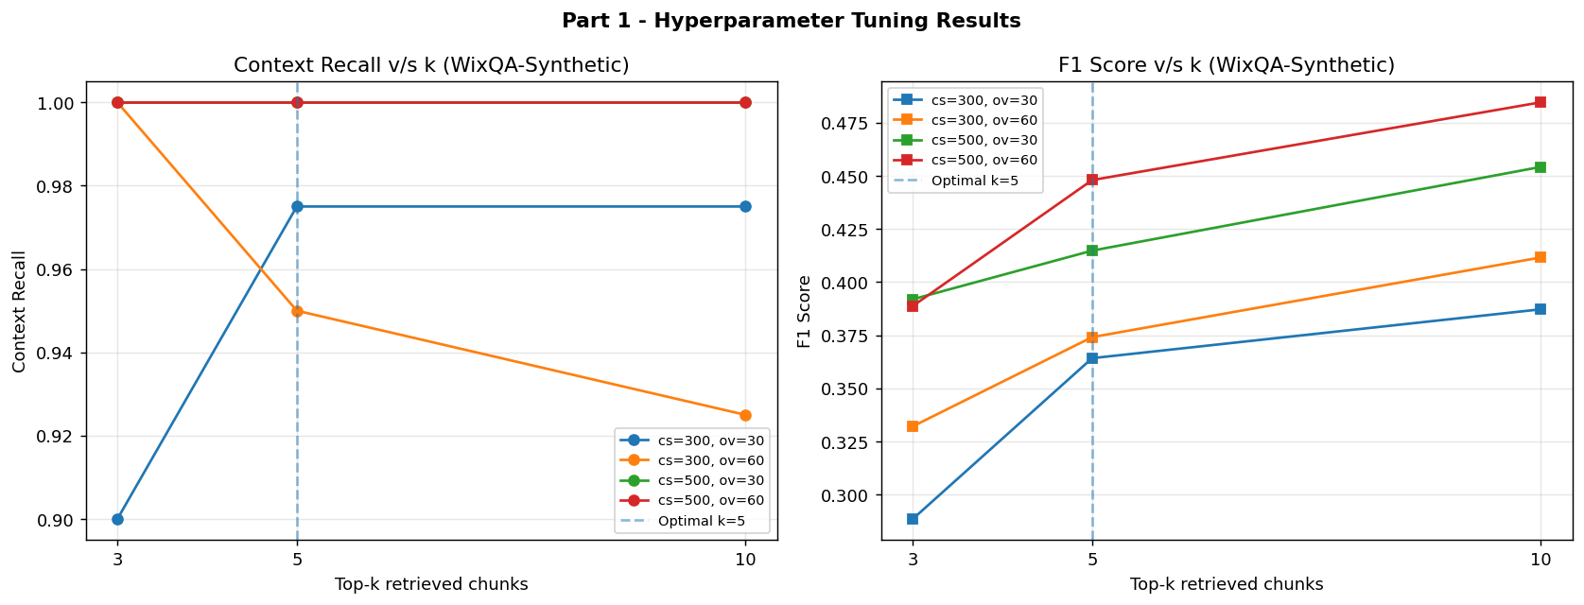

3. Part 2 - Retrieval Evaluation (Context Recall)
Context Recall was measured on both final evaluation sets using the optimal config (chunk_size=500, overlap=60, k=5). An LLM judge (temperature=0) assessed whether each retrieved context contained enough information to answer the query.

Dataset | Optimal Chunk | Optimal Overlap | Optimal k | Context Recall | Observation
WixQA-ExpertWritten | 500 | 60 | 5 | 0.96 | Retrieval highly consistent; expert queries align well with KB vocabulary
WixQA-Simulated | 500 | 60 | 5 | 0.94 | Slight drop in recall; informal phrasing leads to vocabulary mismatch with KB

Both datasets showed strong retrieval (0.96 and 0.94). ExpertWritten scored marginally higher because expert questions use terminology that directly matches the KB articles. The small drop on Simulated reflects vocabulary mismatch from informal phrasing, which occasionally causes the retriever to miss the best chunks.

4. Part 3 - Generation Evaluation
The baseline system was evaluated on F1 (token overlap), ROUGE-1 (unigram coverage), ROUGE-2 (bigram coverage), and Factuality (LLM judge returning 1 if the generated answer preserves the essential meaning of the reference without contradiction).

Dataset | F1 | ROUGE-1 | ROUGE-2 | Factuality
WixQA-ExpertWritten | 0.2763 | 0.3058 | 0.1775 | 0.4
WixQA-Simulated | 0.1807 | 0.2213 | 0.1128 | 0.85

ExpertWritten produced higher overlap scores (F1=0.27, ROUGE-1=0.30) but lower factuality (0.40). Simulated showed lower overlap but much higher factuality (0.85). This reflects a difference in reference answer style: expert references are detailed and specific, so the LLM's paraphrased responses score lower on token overlap even when the content is correct. Moderate F1 and ROUGE scores overall are expected since the model rewrites rather than copies retrieved text.

5. Part 4 - System Improvements
Three improvements were evaluated against the baseline. Generator, embedding model, vector store, and prompt were kept fixed in all cases.

5.1 Descriptions
Semantic Chunking: SemanticChunker (LangChain Experimental) was used to split documents at points where sentence-embedding similarity drops below the 95th-percentile threshold, keeping semantically related sentences together instead of cutting at fixed character counts.
Reranking: A two-stage approach retrieved the top-50 candidates via FAISS, then a cross-encoder (cross-encoder/ms-marco-MiniLM-L-6-v2) rescored them and kept the top-k=5 highest-scoring chunks for generation.
Query Rewriting: The LLM rewrote each user query into a concise, keyword-rich search query before FAISS retrieval. The original query was still used for generation.

5.2 Comparative Results
System | Dataset | Context Recall | F1 | ROUGE-1 | ROUGE-2 | Factuality
Baseline RAG | WixQA-ExpertWritten | 1.0 | 0.2763 | 0.3058 | 0.1775 | 0.4
Baseline RAG | WixQA-Simulated | 0.9 | 0.1807 | 0.2213 | 0.1128 | 0.85
+ Semantic Chunking | WixQA-ExpertWritten | 0.9 | 0.1178 | 0.1333 | 0.0756 | 0.6
+ Semantic Chunking | WixQA-Simulated | 0.8 | 0.1087 | 0.1197 | 0.0474 | 0.75
+ Reranking | WixQA-ExpertWritten | 1.0 | 0.3213 | 0.3355 | 0.1963 | 0.3
+ Reranking | WixQA-Simulated | 0.9 | 0.2395 | 0.293 | 0.1674 | 0.9
+ Query Rewriting | WixQA-ExpertWritten | 0.95 | 0.2522 | 0.2803 | 0.1495 | 0.5
+ Query Rewriting | WixQA-Simulated | 0.95 | 0.1959 | 0.2452 | 0.1069 | 0.75

5.3 Delta vs Baseline
System | Dataset | ΔContext Recall | ΔF1 | ΔROUGE-1 | ΔROUGE-2 | ΔFactuality
+ Semantic Chunking | WixQA-ExpertWritten | -0.1 | -0.1585 | -0.1725 | -0.1019 | 0.2
+ Reranking | WixQA-ExpertWritten | 0.0 | 0.045 | 0.0297 | 0.0188 | -0.1
+ Query Rewriting | WixQA-ExpertWritten | -0.05 | -0.0241 | -0.0255 | -0.028 | 0.1
+ Semantic Chunking | WixQA-Simulated | -0.1 | -0.072 | -0.1016 | -0.0654 | -0.1
+ Reranking | WixQA-Simulated | 0.0 | 0.0588 | 0.0717 | 0.0546 | 0.05
+ Query Rewriting | WixQA-Simulated | 0.05 | 0.0152 | 0.0239 | -0.0059 | -0.1

5.4 Analysis
Reranking was the only improvement that consistently helped. It raised F1 by +0.05 on ExpertWritten and +0.06 on Simulated, and ROUGE-1 by +0.03 and +0.07 respectively. The cross-encoder is better at ranking relevant chunks than cosine similarity alone, so the final top-5 chunks sent to the LLM were more focused, improving answer quality.
Semantic Chunking hurt F1 significantly (-0.15 on ExpertWritten, -0.07 on Simulated). The main reason is that only the first 600 articles were semantically chunked due to processing time, creating an inconsistent index. Factuality improved (+0.20 on ExpertWritten), suggesting semantic chunks are cleaner when retrieved, but the reduced coverage outweighed this benefit.
Query Rewriting had mixed results. On ExpertWritten it slightly hurt metrics because those queries were already well-structured. On Simulated it improved Context Recall by +0.05 and ROUGE-1 by +0.02, confirming that informal queries benefit from being reformulated into KB-friendly search terms before retrieval.

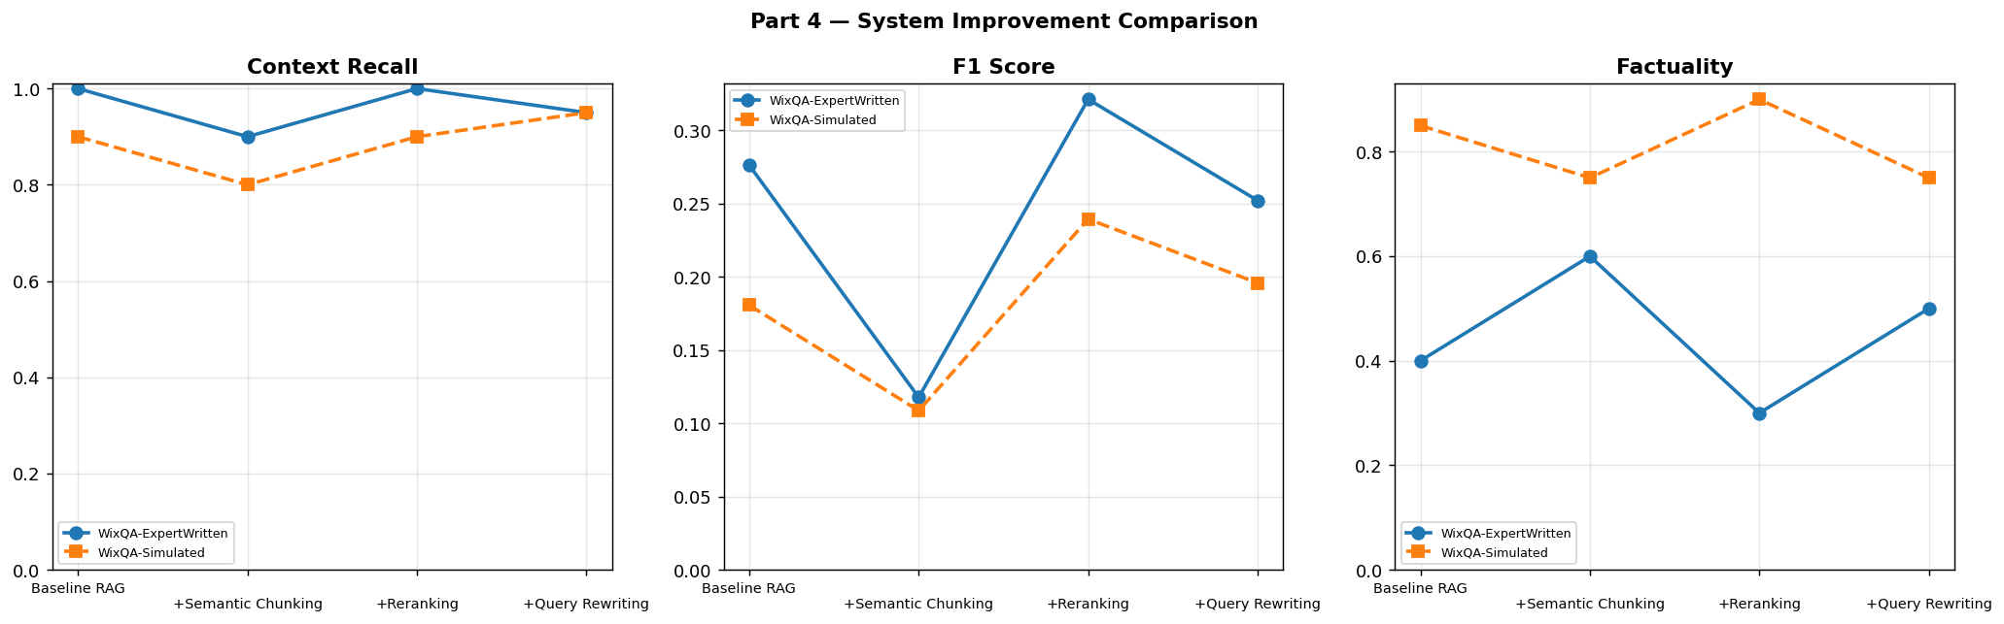

6. Screenshots
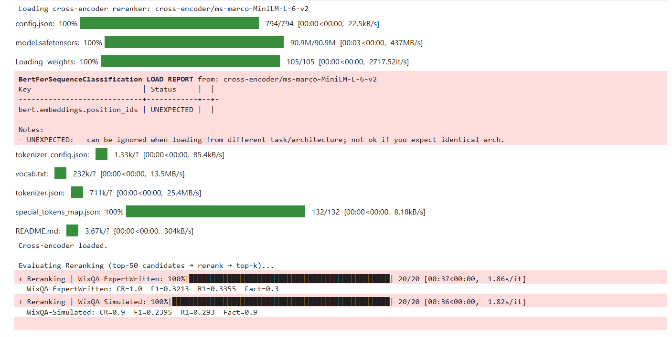

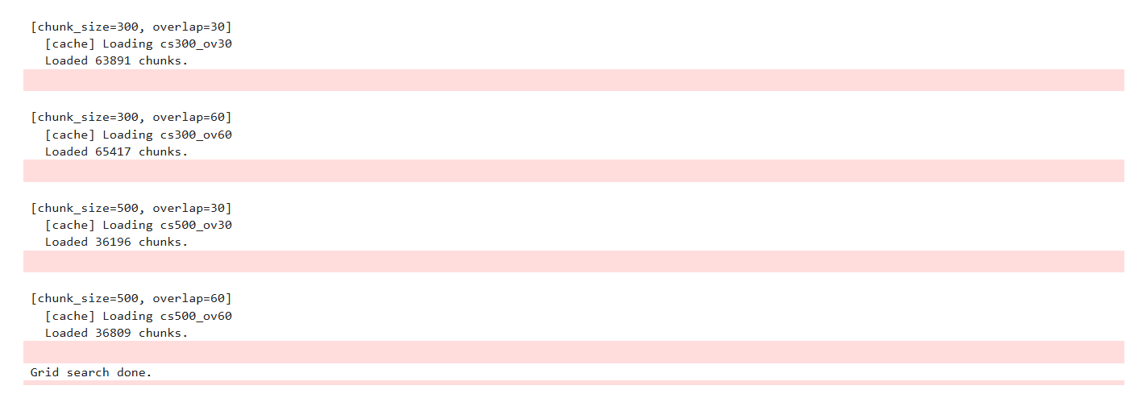

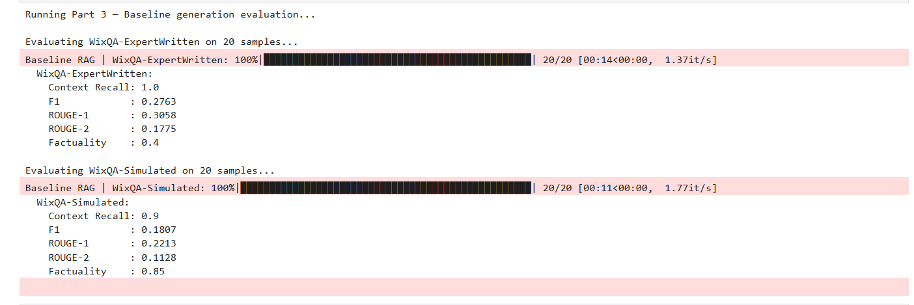

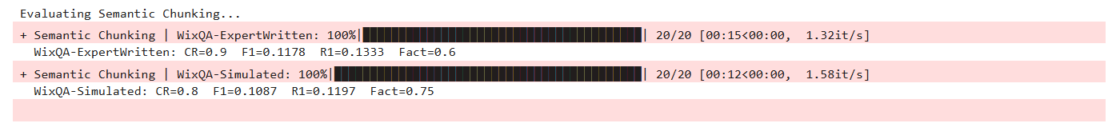
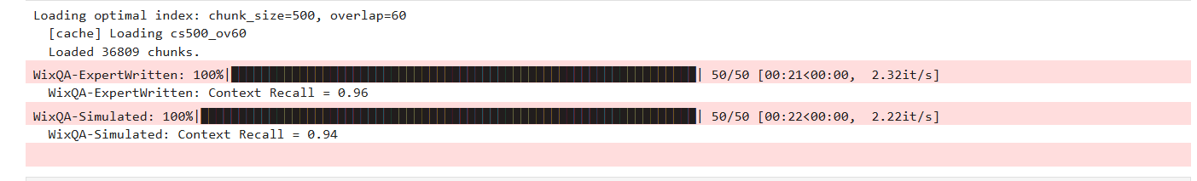

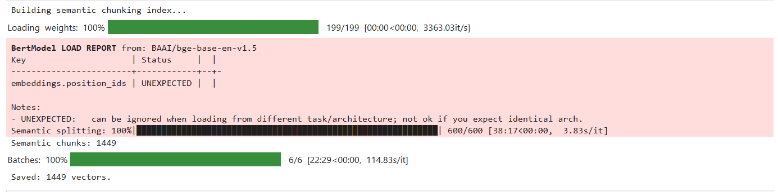

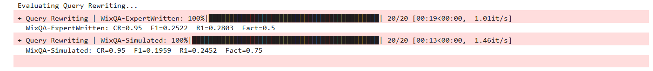

7. Summary
Part | Key Metric | Finding
Part 1 | Optimal: cs=500, ov=60, k=5 | Larger chunks with moderate overlap gave best recall-generation balance.
Part 2 | CR=0.96 (Expert), CR=0.94 (Sim) | Strong retrieval on both sets. Expert queries align better with KB vocabulary.
Part 3 | F1=0.27 (Expert), F1=0.18 (Sim) | Moderate lexical overlap expected given LLM paraphrasing. Factuality higher on Simulated.
Part 4 | Best: Reranking (+0.05 F1) | Cross-encoder reranking was the only consistent improvement across both datasets.

